THIRD SUNDAY AFTER PENTECOST |  | CHRIST CHURCH GABRIOLA  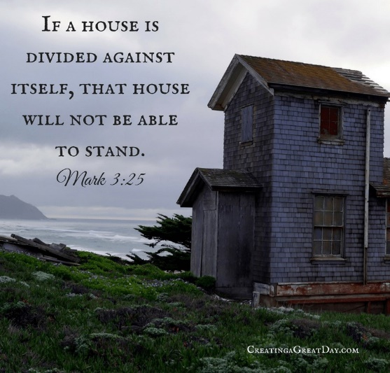  June 10th, 2018
Readings for Sunday June 3rd Service
1 Samuel 3:1-10 (11-20), Psalm 139:1-6, 13-18,2 Corinthians 4:5-12, Mark 2:23-3:6

Communion Services are held on the First and Third Sunday of the month.

 | Rev. Karen’s Regular Office Hours
 | 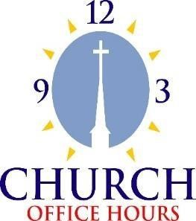 | Karen's drop-in office hours are Tuesday and Wednesday 1:00 - 3:00.  If these times don't work for you, please phone the church 250-247- 8633, or email her RevKarenHollis@gmail.com to make an appointment.  Christ Church Gabriola website- www.christchurchgabriola.ca
From the Desk of Rev. Karen.
At the beginning of our council meetings for the past 6 months we've been praying for the church. We pray for people, for ministries, for a vision for the future. This week when I was preparing our council prayer time I realized the prayer of our church is contained in the report I had just written to council. This prayer contains the heart of our church as expressed in the gatherings earlier in the year. In addition to including this prayer in our Sunday morning worship, I invite you to use this prayer in your personal prayer time. Print it out and put it in your Bible, devotional or journal, or hang it somewhere you will see it. Let us use these words to pray together for the life of our community.
blessings, Karen

Prayer for Our Community
We pray in thanksgiving for what we have accomplished as a community, not just for merging the two congregations together, but for the ethos of love and care that has developed in our midst through the process. “We care for each other;” “we are committed to listening, our work ethic, a sense of belonging;” “Christ is present with us.” Commitment to our community through Christ is the foundation on which all else is built as we move forward. God in your mercy . . .
Hear our prayer
God, we are experiencing a healthy tension in worship between embracing our ecumenical reality and naming our particular preferences in worship. While we cannot deny the ways in which we are formed and the elements of worship that feed our souls, the form of our worship seeks to make room for all. We love to hear you in silence and in the beating of our hearts. We wonder about creative things we might try in worship, as we recognize one of the gifts of our Anglican/United identity as that creative tension of tradition and innovation in our practice. Hold us in the tensions we find in our worship; help us to challenge ourselves to be in discomfort and find gifts in it; and help us to rest in the parts of worship we experience as home. God in your mercy . . .
Hear our prayer
We give thanks for music as praise and worship of you, O God. We give thanks for the ways in which it helps us connect with deeper parts of ourselves and helps us open ourselves to you. While we all don’t agree on which types of music gives us this experience, we pray for real patience to make space for the other and pray for the continued growth and health of our music program. Help us to live lives in you through song. Thank you for all who share their joy of singing and help it spread throughout the congregation. Thank you for the way you speak to us through verses and hymns, melodies and harmonies! God in your mercy . . .
Hear our prayer
God bless your Word in our midst and the Word in our lives. Bless the gatherings where we look at how your word speaks into our living and give us the courage to respond. Help us to grow our gatherings; clear people’s schedules; help us find locations that work for people; stir the hearts of potential leaders and help them find the courage they need to respond. We pray for one in our midst who feels a sense of call to gathering the men in our community, for a meaningful gathering for men to connect and explore their spirituality. God in your mercy . . .
Hear our prayer
God, we know the importance of worship and study, and yet sometimes we just want to have fun together, so bless those in our midst who bring us together just for fun. Bless their ideas and help them bring events together with ease. Make these gatherings a place where friendships can grow and even newcomers feel like they belong. Help us to kick back and waste time together in this piece of your beautiful creation. God in your mercy . . .
Hear our prayer
Comforter, we work so hard to care for each other. We give thanks for our sisters and brothers in Christ who visit, write, cook and offer their time and energy to those who have specific needs in our community. We give thanks for those who don’t fuss, but simply respond to the needs and do so with a servant heart in the name of Christ. Bless those who are serving in this way and tend to their hearts and spirits in their fatigue. Caring for the community is a community task, so we pray that you would stir all of our hearts toward caring for each other more deeply and more fully. God in your mercy . . .
Hear our prayer
We lift up to you, Our Creator, the many outreach ministries of our church: PHC lunch, Shawl Ministry, Christmas Alive, sending cards to people, the Strawberry Tea and more. We give thanks for the many people who step up to help when needs arise. We wonder and we pray, O God: are more ways in which we can connect with and serve the Gabriola community? Are we ready for a big project? What is the need on the island? How can we offer our space? With whom can we partner? What does it look like to be the church in the world? What about Reconciliation? Where would you have us focus our energy and resources? God in your mercy . . .
Hear our prayer
God of Hope and Possibilities, at their best, your communities are intergenerational, and so we pray for children, we pray for young families, we pray for balance to be restored in our midst so that this community of faith may continue through the generations to do the work of Christ in the world. Speak to us that we may hear what welcome looks like to young families; what belonging looks like; what discipleship looks like; speak to us that we may hear what the future looks like through your eyes. Be in our hearts and minds, be our vision that we may create through our devotion to you a truly sustainable ministry. Give us grace and healing where we struggle to change, where we want to hold on, and love us in our becoming. God in your mercy . .
Hear our prayer
We ask a special blessing on our church leaders and minister. Help us to lead from the faith we know in you, the faith that is sustained through worship and community life. May we as leaders of the church be an example and support for others on their faith journeys. Bless us with ideas, opportunities and possibilities that we may focus our efforts, becoming a more vibrant, sustainable, faithful and intergenerational community of faith, and that our ministry would have a substantial impact on our wider community. God in your mercy . . .
Hear our prayer, Amen

(A copy of these prayers is attached to the announcements)

Safe Church Training Session
A 3-hour facilitated Safe Church training session will be held at Christ Church Gabriola on of misconduct that can occur in situations when there is an imbalance of power. The training is provided free-of-charge by the Diocese of BC and is heartily endorsed by BC Conference. The training session is open to all members of the congregation. However, church volunteers in positions of trust and authority and those in contact with vulnerable adults are especially urged to attend.
Pre-registration is necessary, so please sign-up on the sheet in the church hall. Contact Rob Brockley for more information.
- Saturday, June 16, 2018
- 10:00AM - 1:00PM

Lectionary Bible Study Tuesday Mornings!

Please join us on Tuesdays at 10am for a conversation on the
lectionary texts for the coming Sunday. All are welcome! Those are lectors and leading prayers that week may find
attending particularly helpful for their
preparation. So, come and gather for study, prayer and a time of
sharing.

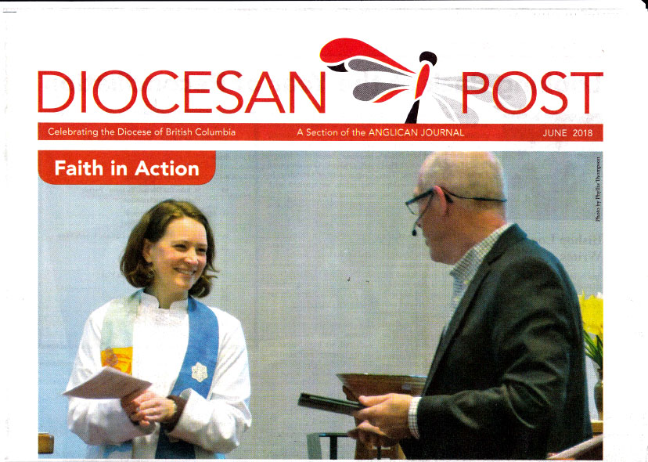
June, 2018
The Diocesan Post - A section of the Anglican Journal

The Covenanting of Rev. Karen Hollis: Faith in Action
On April 15, the atmosphere inside the small church on Gabriola Island was alive with welcoming words and last-minute activity as all awaited the Covenanting Service that would officially bind the congregation to its new incumbent, Rev. Karen Hollis and give that worshipping community its new name.
The church is a shared ministry, melded from the original churches, St. Martin of Tours Anglican and Gabriola United. To read about the history that brought the two congregations together and the process that led up to the April 15 Covenanting service, see the DP’s May 2017 issue and the lead article by Rev. Peggy Jensen. www.bc.anglican.ca/news/may2017-diocesan-post
Andy Gilman, Chair of the Comox/Nanaimo Presbytery for the United Church, led the service, opening with words about covenant—how God was a maker and keeper of covenants and was good at keeping the covenants made with humans, whereas humans often fell short. Covenants “bind us together in mutual agreement, where all do their part,” he said. A covenant is a rite of passage for both parties, with promises made one to another. “It celebrates a new relationship, it’s meant to be joyful,” Gilman said.
Gilman also touched on the history this congregation lived and worked through as it decided to be a shared worshipping community and ministry on Gabriola Island. These individuals “by their patience, listening, thoroughness and careful discernment, have paved the way for others,” he said.
After the call to worship and opening prayer, people were thanked for their involvement in the discernment and transition processes, and on the search committee. Then Rev. Gail Miller, representing the B.C. Conference of the United Church, introduced the new incumbent, Rev. Karen Hollis.
After scriptural passages were read, Rev. Jim Holland, Anglican chaplain at Shawnigan Lake School and a member of this church’s transition team, preached. He spoke about tradition and the kinds of difficulties that are always present when change happens, particularly as a group works toward resolution and compromise. He noted this group honoured the “challenging work of bringing together different worship styles” and said it represents the spirit of the early church. He said that as this shared community discerned its future, it has become a safe, welcoming place, now supported by Karen’s commitment to stand with the congregants on this new journey.
Andy Gilman led the actual Act of Covenanting, where Hollis responded to various questions and where the congregation also took part in this exchange of promises. Symbols of Hollis’ new position were presented to her: a bible, a chalice, a pitcher of water, and a piece of driftwood. Gilman said each was “a sign of the new ministry that is ours and yours in this presbytery.”
Anglican Bishop, Logan McMenamie, attended to the final official part of this service. First, he offered the support and prayers of this diocese. He then noted that the history leading to this day had been one “of journey, of pilgrimage, of hard work and witness.” He pointed out that in scripture God re-named those who were specially called. “Their new identity reflected a new ministry, reflected a spirit quest to be closer to others,” he said. Here, too. Bishop Logan then officially gave this congregation its new name: Christ Church Gabriola. The service ended with the new incumbent commissioning the entire congregation and offering a benediction. A gracious reception followed.
Here, I add a personal comment about how much music at any liturgical service matters to me. That day offered some special and meaningful pieces. I mention two: a prelude, with pianist Marilyn Smith and guitarist Jim Hollis, accompanying a duet sung by Karen Hollis and husband Jim— Rend Collective’s “Build Your Kingdom Here” with phrases like “Set our hearts ablaze with hope; like wildfire in our very souls, Holy Spirit invade us now.” “We are your church, set your church on fire.” The other: a postlude, again with Marilyn at the piano and Jim singing “Shine On Us” by Deborah and Michael Smith, and phrases like “Light shine on us, grace fall on us, love with no end come over us, that we may have life.” Perfect musical bookends for this service of new ministry.
https://bc.anglican.ca/news/june-2018-diocesan-post
Written by Phyllis Thompson who is the proofreader for the Diocesan Post and also a contributor to it.

Belated Happy Anniversary to Richard and Carolyn Pullano
June 5th

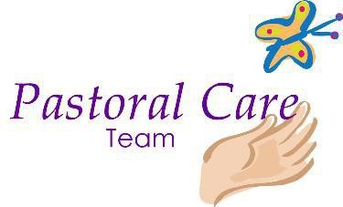

If you, or someone you know, requires emergency pastoral care please phone the church office ph # 250-247-8633 for further contact information. The Pastoral Care Team will continue to provide regular pastoral care for members of the congregation. Email: christchurchgabriola@gmail.com
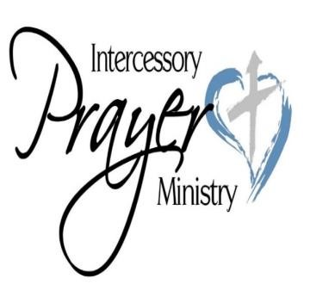
PRAYER WHEEL
To request prayers for someone OR to become a member of the prayer wheel and pray for others as requested, please contact Susan Brockley: or phone the church office ph # 250-247-8633 Email: christchurchgabriola@gmail.com
Church Humour

All Are Welcome to Worship Together
We welcome you, whoever and wherever you are, to join us on a journey. We strive to accept each other as we are and welcome the ministry and participation of all persons regardless of age,
gender identity, health, race, sexual orientation, differing abilities, religious or ethnic background or economic circumstance.
We hope that in all that we do, in our worship and community life, that the Creator’s unconditional love is experienced.
We do this trusting The Creator is with us on the journey.

We gather on the ancestral lands the Snuneymuxw people.

Minister: Rev. Karen Hollis
Musician: Marilyn Smith

Office: 2600 South Rd. Gabriola BC V0R 1X7 250-247-8633
Email: christchurchgabriola@gmail.com
Website: www. christchurchgabriola.ca

Office Administrator: lisamillard@shaw.ca
Communications: hplowright@shaw.ca

We hope that in all that we do, in our worship and community life, that the Creator’s unconditional love is experienced.
We do this trusting The Creator is with us on the journey.

We gather on the ancestral lands the Snuneymuxw people.

