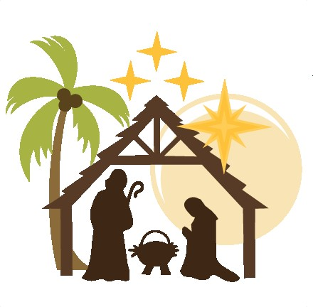

Christmas Services Schedule:

December 21 - Blue Christmas 7pm December 24 - 7pm Lessons and Carols
December 24 - 11pm Candlelight Eucharis
December 25 - 10am Christmas Morning Eucharist

